**TASK**

**Task 1**

**HTML Code**

<html>

<head>

<title>Global Temperatures</title>

<link rel="stylesheet" href="first.css">

</head>

<body>

<div>

<caption>Average Annual Global<br>Temperatures</caption>

<table>

<tr>

<th>Year</th>

<th>Temp<br>Rank</th>

<th>Avg<br>Temp(°F)</th>

</tr>

<tr>

<td class="first">2016</td>

<td>1</td>

<td>58.98</td>

</tr>

<tr>

<td class="first">2015</td>

<td>2</td>

<td>58.77</td>

</tr>

<tr>

<td class="first">2014</td>

<td>3</td>

<td>58.53</td>

</tr>

<tr>

<td class="first">2013</td>

<td>5</td>

<td>58.37</td>

</tr>

<tr>

<td class="first">2012</td>

<td>9</td>

<td>58.33</td>

</tr>

</table>

</div>

</body>

</html>

**CSS Code**

* {

text-align: center;

}

table {

margin-top: 1px;

text-align: center;

margin-left: auto;

margin-right: auto;

}

table, td, th {

border: 1px solid white;

border-collapse: collapse;

}

th, td {

padding-top: 5px;

padding-bottom: 5px;

padding-left: 12px;

padding-right: 12px;

}

th {

background-color: #00008B;

color: white;

}

td {

background-color: #e3be9b;

}

.first {

background-color: purple;

color: white;

}

**Output:**

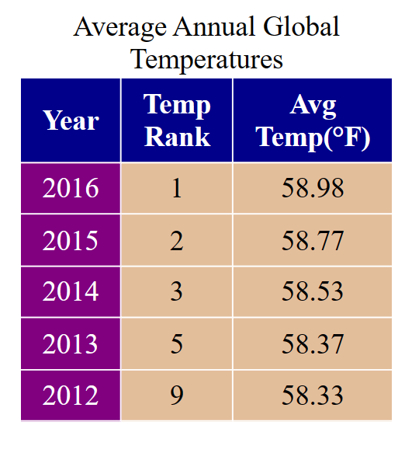

**Task 2**

**HTML Code**

<!DOCTYPE html>

<html>

<head>

<title>Design Web Page</title>

<style>

#table,

th {

border: 1px solid black;

margin: 10px;

padding: 6px;

}

#table {

border-spacing: 0px;

}

td {

padding: 0 5px;

}

</style>

</head>

<body>

<h2 style="color: orange">Land Of Boxes Order Form</h2>

<form>

<table>

<tr>

<td>

<label for=""> Name: </label>&nbsp;&nbsp;&nbsp;&nbsp;&nbsp;

<input type="text" name="name" value="Walaa Brody"/><br /><br />

</td>

</tr>

<tr>

<td>

<label for=""> Email: </label>&nbsp;&nbsp; &nbsp;&nbsp;&nbsp;

<input type="email" name="email" value="w.brody@widget-sales.com"/><br /><br />

</td>

</tr>

<tr>

<td>

<label for=""> Address: </label>&nbsp;

<textarea rows="4" cols="50">162 Main Road

Rondebeach

CapeTown

</textarea><br /><br />

</td>

</tr>

<tr>

<td>

<label for="">PostCode: </label

><input type="number" name="postcode" value="7700" /><br /><br />

</td>

</tr>

</table>

<br />

<table id="table" border="1">

<tr>

<th>Product</th>

<th>Part Number</th>

<th>Quantity</th>

<th>Unit Price</th>

<th>Subtotal</th>

</tr>

<tr>

<td>EconoBox</td>

<td>LB100</td>

<td><textarea cols="8" rows="1">3</textarea></td>

<td>R5</td>

<td><textarea cols="8" rows="1">R15</textarea></td>

</tr>

<tr>

<td>Standard Box</td>

<td>LB200</td>

<td><textarea cols="8" rows="1">4</textarea></td>

<td>R10</td>

<td><textarea cols="8" rows="1">R40</textarea></td>

</tr>

<tr>

<td>Premium Box/TD</td>

<td>LB300</td>

<td><textarea cols="8" rows="1">1</textarea></td>

<td>R15</td>

<td><textarea cols="8" rows="1">R15</textarea></td>

</tr>

<tr>

<td>Deluxe Box/TD</td>

<td>LB400</td>

<td><textarea cols="8" rows="1">0</textarea></td>

<td>R20</td>

<td><textarea cols="8" rows="1"></textarea></td>

</tr>

<tr>

<td>Super Deluxe Box/TD</td>

<td>LB500</td>

<td><textarea cols="8" rows="1">1</textarea></td>

<td>R30</td>

<td><textarea cols="8" rows="1">R30</textarea></td>

</tr>

<tr>

<td colspan="4">Total</td>

<td><textarea cols="8" rows="1">R100</textarea></td>

</tr>

</table>

<br />

<h2>Credit Card Details</h2>

Card Type :<br /><br />

<input type="radio" name="cardType" value="Mastercard" checked />

<tr>

<td></td>

</tr>

<label for="">Mastercard</label>

&nbsp;&nbsp;&nbsp;&nbsp;&nbsp;&nbsp;&nbsp;&nbsp;&nbsp;

<label for="">Card Number :</label>&nbsp;

<input type="number" name="cardnumber" value="45645"/><br /><br />

<input type="radio" name="cardType" value="Visa" />

<label for="">Visa</label

>&nbsp;&nbsp;&nbsp;&nbsp;&nbsp;&nbsp;&nbsp;&nbsp;&nbsp;&nbsp;&nbsp;&nbsp;&nbsp;&nbsp;&nbsp;&nbsp;&nbsp;&nbsp;&nbsp;&nbsp;&nbsp;

<label for="">Expiry Date :</label>&nbsp; &nbsp;

<input type="date" name="date" /><br /><br />

<input type="radio" name="cardType" value="AmericanExpress" />

<label for="">American Express</label><br /><br />

<input type="radio" name="cardType" value="dinnersclub" />

<label for="">Dinners Club</label><br /><br />

<b><label for="">Delivery Address:</label></b> &nbsp;&nbsp;

<textarea rows="4" cols="50">162 Main Road

Rondebeach

CapeTown</textarea><br /><br />

<input type="submit" value="Send Order" /> &nbsp;&nbsp;

<input type="reset" name="Clear" value="Clear form" />

</form>

</body>

</html>

**Output:**

